Uplift Project:
Mastectomy bras and breast forms
advice sheet:

www.upliftbras.org

p1 Fitting bras after a mastectomy
How to measure bra size

p2 How to measure for a soft bra and soft form

p3 How to select a mastectomy bra and breast form

p4 Fitting the breast form
Care of the breast form

p5 How to convert an ordinary bra to a mastectomy bra

How to make a home-made seed or grain filled breast form

1
Fitting Bras after a Mastectomy
In the first 6 weeks post surgery a soft bra and soft breast form may be used, if available. Once the swelling has gone down and wound healing is complete a mastectomy bra and breast form can be fitted. Fitting each of these starts with measuring bra size at the time. Bra size may change as swelling goes down.

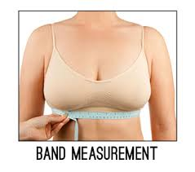
How to measure bra size

You need to measure the body/band size and cup size to work out the bra size.
Step 1: Body/band size is measured around the torso just under the base of the breasts, where the band of the bra sits.
The woman should be standing and may have her bra on. The tape measure should be firm and snug.

Use the table below to convert the measurement in centimetres to give the first part of the bra size, the body size, as a figure eg 34.

Body Size Measurement

Body (cm)  measurement | 68-72 | 73-77 | 78-82 | 83-87 | 88-92 | 93-97
Body size | 32 | 34 | 36 | 38 | 40 | 42
98-102 | 103-107 | 108-112 | 113-117
44 | 46 | 48 | 50

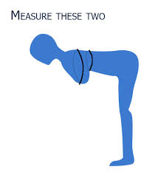
Step 2: The cup size is measured around the fullest part of the breast.
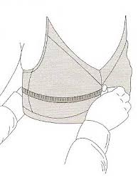
With your tape measure, measure at the fullest part of the remaining breast, from the centre of the sternum/ breastbone to the centre of the spine. If there is no bra to measure in, measure with the woman bent forward.
Double the measurement to determine the cup size.

To measure cup size:

If this measures 8-10 cm more than the body size measurement she will take a AA Cup
If this measures 10-12 cm more than the body size measurement she will take an A Cup
If this measures 12-15 cm more than the body size measurement she will take a B Cup
If this measures 15-18 cm more than the body size measurement she will take a C Cup
If this measures 18-20 cm more than the body size measurement she will take a D Cup
If this measures 20-23 cm more than the body size measurement she will take a DD Cup
If this measures 23-25 cm more than the body size measurement she will take an E Cup

Beyond E cup the sizes are different between UK, USA and Aus systems. A USA DD = Aus E for example, you will need to experiment with bras.

Step 3: The total measurement: These two measurements will give you the two parts of the bra size, the body size as a figure and the cup size as a letter, eg 40C.

2
How to measure for a soft bra and soft form
If soft bras and soft forms ( “Fluffies” or “softies”) are available these can be supplied to patients who have recently had a mastectomy so that they can wear them in the 6 weeks after surgery until they are fitted for their permanent mastectomy bra and breast form. These are not made in the largest sizes so larger ladies may miss out. The sizes for soft bras and soft forms are indicated by different numbers from those used for mastectomy bras and silicone breast forms.
To measure for a soft bra and soft form follow the instructions for measuring body size and cup size as described above. Once you have worked out a bra size then go to the chart below which lists soft bra size and soft form size next to bra size in the first column.

SOFT FORM SIZING CHART
Bra Size | Soft Bra Size | Soft Form Size
32B | 10B | small
32C | 10C | small
32D | 10D | small
34B | 12B | small
34C | 12C | small
34D | 12D | medium
34DD | 12DD | medium
36B | 14B | small
36C | 14C | medium
36D | 14D | medium
36DD | 14DD | large
36E | 14E | large
38C | 16C | medium
38D | 16D | large
38DD | 16DD | large
38E | 16E | x-large
40C | 18C | large
40D | 18D | large
40DD | 18DD | x-large
40E | 18E | x-large
42D | 20D | x-large
42DD | 20DD | x-large

Note: the full size range of soft bras may not be available for you to choose from. But you may be able to substitute a different size soft bra for the bra size you have measured. It may be possible to use a larger cup size with a smaller body size or a smaller body size and larger cup size. For example, soft bras do not come in size 16B but you could substitute for this a soft bra size 14C or 12D.

3
How to select a mastectomy bra and breast form
Measure the current bra size, and select a mastectomy bra to fit.
To find a breast form to match the bra:
- The breast form size is marked on the box and on the inside of the form itself. For example the breast form size might be 4L. This means that the form is for the left side and corresponds to a bra size approximately in the range 32C to 38A. If the black printed size has worn off the breast form it is also imprinted as a raised number on the inside of the form.

The Breast Form Sizing Chart below gives the corresponding breast form size for each bra size. Find the bra size in the first column. The breast form size is given next to it, eg bra size 42C will take a form size 9.
- Most types of breast form go from 0 to 14 in size, though some styles come in larger sizes. The size marked on the breast form will correspond to a particular bra size. Sizes 0 to 3 are in the small range of sizes approximately matching bra sizes 30 to 34, 4 to 8 are in the medium range of sizes approximately matching bra sizes 34 to 40, and 9 to 14 are in the large range of sizes (approximately matching bra sizes 42 +). Cup size for a bra may affect breast form size. For example a woman with a bra size 32D will take a breast form size 5 whereas a woman with a bra size 34B will take a breast form size 4. In other words the larger the cup size, the larger the breast form size.

BREAST FORM SIZING CHART
Bra Size | Breast Form Size |  | Bra Size | Breast Form Size
30AA | 0 |  | 40AA | 5
30A | 1 |  | 40A | 6
30B | 2 |  | 40B | 7
 |  |  | 40C | 8
32AA | 1 |  | 40D | 9
32A | 2 |  | 40DD | 10
32B | 3
32C | 4 |  | 42AA | 6
32D | 5 |  | 42A | 7
32DD | 6 |  | 42B | 8
 |  |  | 42C | 9
34AA | 2 |  | 42D | 10
34A | 3 |  | 42DD | 11
34B | 4
34C | 5 |  | 44A | 8
34D | 6 |  | 44B | 9
34DD | 7 |  | 44C | 10
 |  |  | 44D | 11
36AA | 3 |  | 44DD | 12
36A | 4
36B | 5 |  | 46A | 9
36C | 6 |  | 46B | 10
36D | 7 |  | 46C | 11
36DD | 8 |  | 46D | 12
 |  |  | 46DD | 13
38AA | 4
38A | 5 |  | 48B | 11
38B | 6 |  | 48C | 12
38C | 7 |  | 48D | 13
38D | 8 |  | 48DD | 14
38DD | 9
 |  |  | 50C | 13
 |  |  | 50D | 14

4

Fitting the breast form

Once you have worked out the size of breast form to match the mastectomy bra, she should put on the selected bra. Then get her to raise her arms slightly so that you can slip the breast form into the pocket in the bra through the opening in the side.

Ask her to bend forwards a little and then stand up straight again so that the bra and breast form is sitting comfortably. The breast form should fill out the bra cup both at the top and bottom, preferably without showing outside the edges of the bra cup.

Check the wearer and the bra with the breast form from all angles for shape and symmetry with the other breast.

Get the wearer to make sure she is happy with the fit. She might want to check how she looks with her usual clothes on. You may need to try several different breast forms in the selected bra to get just the right fit.

For a woman who has had a double mastectomy measure body size as described above. You can then choose a bra and breast form size that is suitable for her body size. It may be that her breast forms with her mastectomy bra will give her a smaller or larger size bust size than she had previously. The main thing is that she is comfortable and does not look or feel top heavy or bottom heavy.

Care of the breast form

It is easy to care for the breast form. It should be washed in warm soapy water after use and patted dry with a soft towel. If the box is available it can be stored in the mould inside the box. Be careful not to tear the surface of the breast form with jewellery or sharp finger nails etc. The breast form should provide the wearer with a couple of years of daily wear.

5

How to convert an ordinary bra to a mastectomy bra

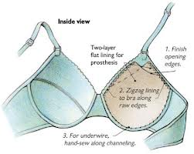

Sometimes you will have a breast form, or can make a breast form, but you do not have a mastectomy bra to fit it.

You can convert an ordinary bra. The diagram here shows how to make a pocket in the bra to hold the breast form.

Any soft, washable material that will fit inside the bra will be suitable.

How to make home-made seed or grain filled breast forms

To make these forms you'll need a small grain, such as flaxseed, birdseed or rice, and flesh-coloured stockings/pantyhose.
- Get a pair of knee-high stockings that are of medium width (you don't want them to be too sheer or too thick) or a pair of pantyhose and cut them off at the knees. Check for any runs or tears which could let seed leak out.
- Use a funnel or a rolled sheet of paper to fill the stocking as shown below.
- To get the right size, use your mastectomy bra as a guide.
- Once you have filled up the stocking, use a rubber band to secure the top.
- Wait a few days before you try on the form to give the grain or seed time to settle and the nylon more time to stretch so it will mould against your body.
- Once you put it on, you can adjust for size by adding more seed or taking some out.
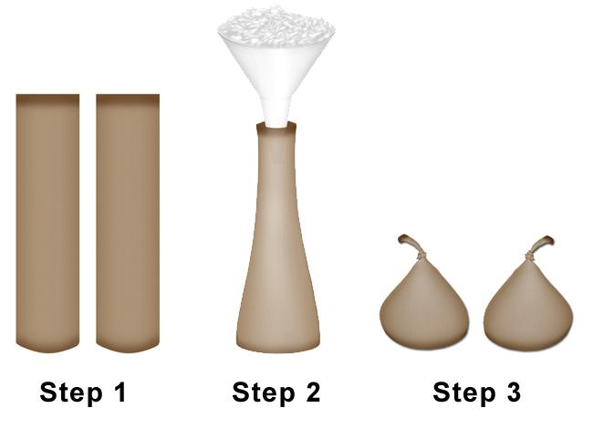
- Once the size is right, tie it in a knot at the top. It is safer to use a rubber band as well to secure the knot.

Uplift would like to thank the Breast Care Network Australia for kindly giving permission to use their Guidelines for ordering the My Care Kit in compiling these instructions.

